You are given an array points where points[i] = [xi, yi] is the coordinates of the ith point on a 2D plane. Multiple points can have the **same** coordinates.

You are also given an array queries where queries[j] = [xj, yj, rj] describes a circle centered at (xj, yj) with a radius of rj.

For each query queries[j], compute the number of points **inside** the jth circle. Points **on the border** of the circle are considered **inside**.

Return *an array*answer*, where*answer[j]*is the answer to the*jth*query*.

**Example 1:**

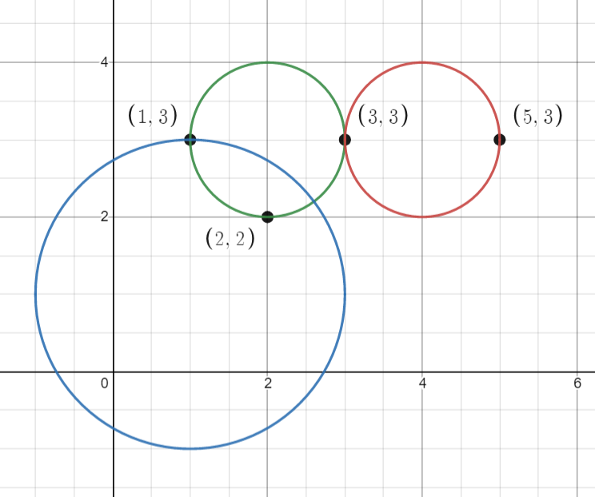

**Input:** points = [[1,3],[3,3],[5,3],[2,2]], queries = [[2,3,1],[4,3,1],[1,1,2]]

**Output:** [3,2,2]

**Explanation:** The points and circles are shown above.

queries[0] is the green circle, queries[1] is the red circle, and queries[2] is the blue circle.

**Example 2:**

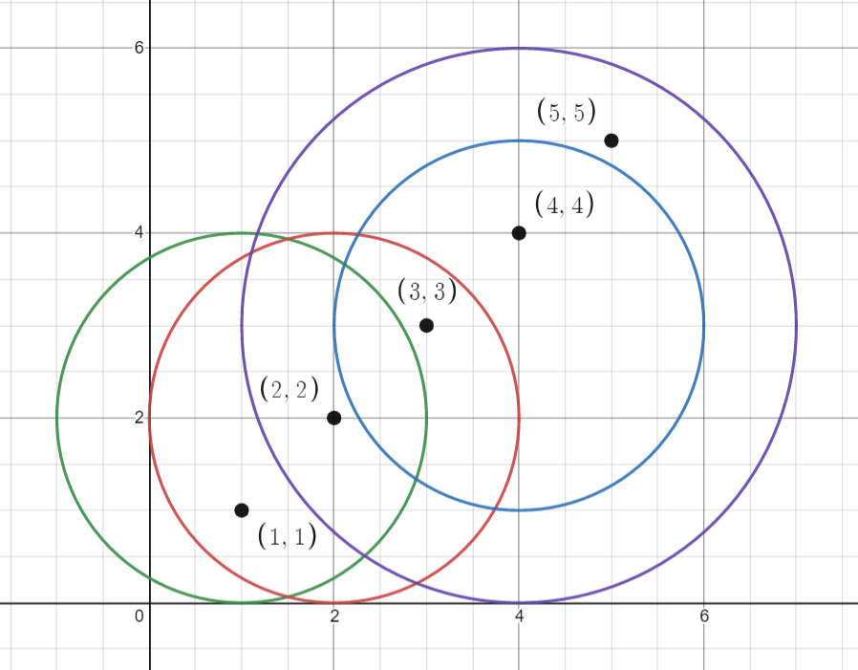

**Input:** points = [[1,1],[2,2],[3,3],[4,4],[5,5]], queries = [[1,2,2],[2,2,2],[4,3,2],[4,3,3]]

**Output:** [2,3,2,4]

**Explanation:** The points and circles are shown above.

queries[0] is green, queries[1] is red, queries[2] is blue, and queries[3] is purple.

**Constraints:**

* 1 <= points.length <= 500
* points[i].length == 2
* 0 <= x​​​​​​i, y​​​​​​i <= 500
* 1 <= queries.length <= 500
* queries[j].length == 3
* 0 <= xj, yj <= 500
* 1 <= rj <= 500
* All coordinates are integers.

**Follow up:** Could you find the answer for each query in better complexity than O(n)?